**Tracing Letter “Aa”**

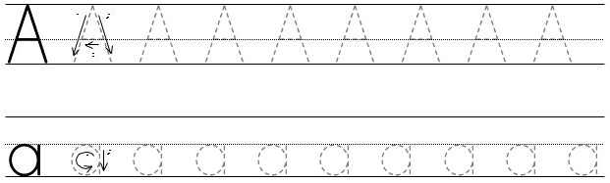







**Tracing Letter “Bb”**

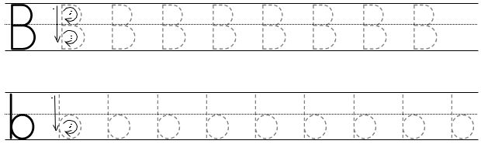







**Tracing Letter “Cc”**

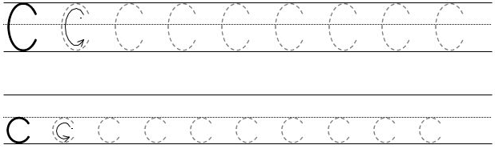







**Tracing Letter “Dd”**

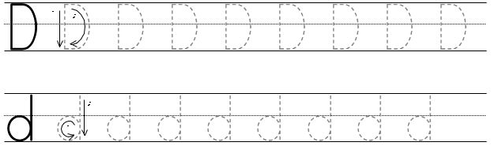







**Tracing Letter “Ee”**

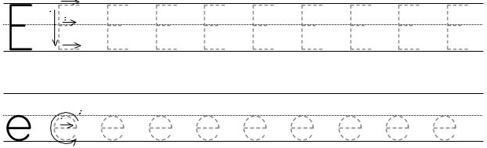







**Tracing Letter “Ff”**

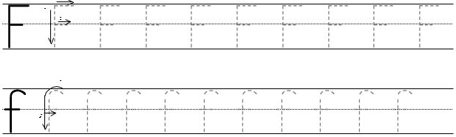







**Tracing Letter “Gg”**

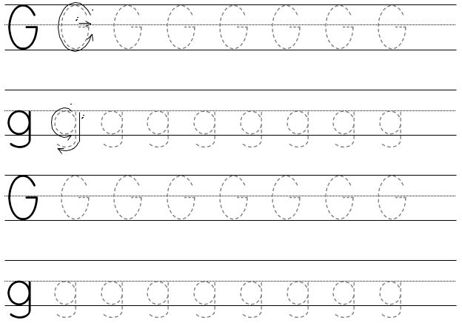



**Tracing Letter “Hh”**

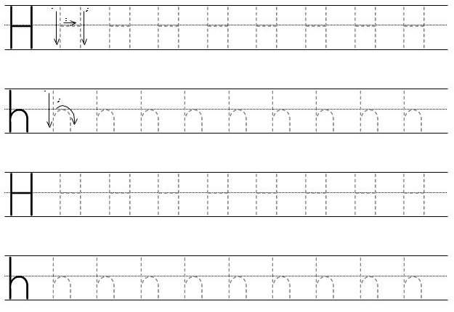



**Tracing Letter “Ii”**

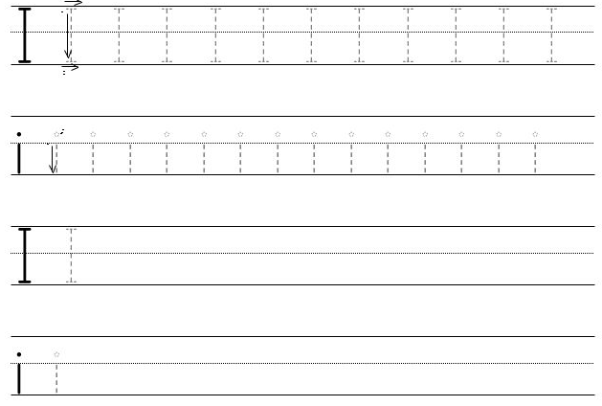



**Tracing Letter “Jj”**

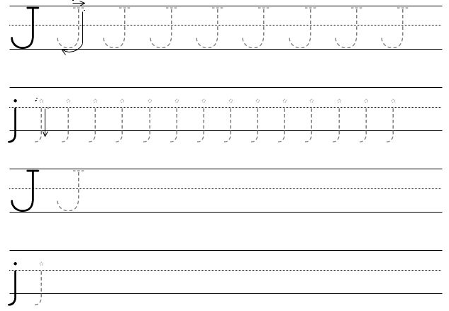



**Tracing Letter “Kk”**

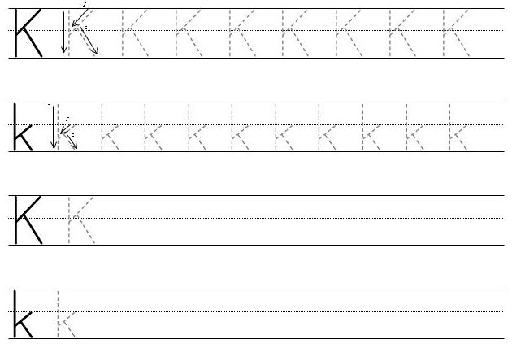



**Tracing Letter “Ll”**

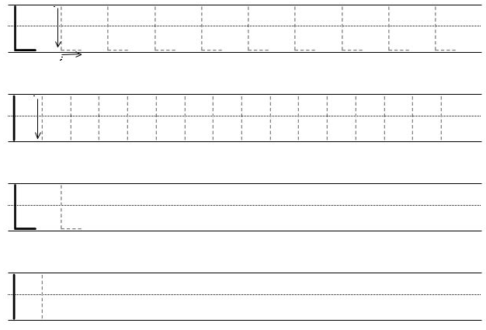



**Tracing Letter “Mm”**

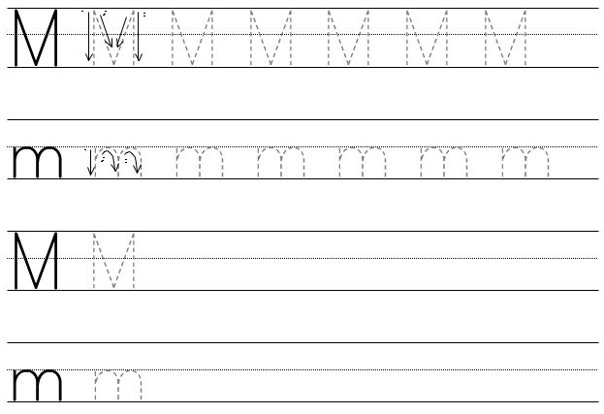



**Tracing Letter “Nn”**

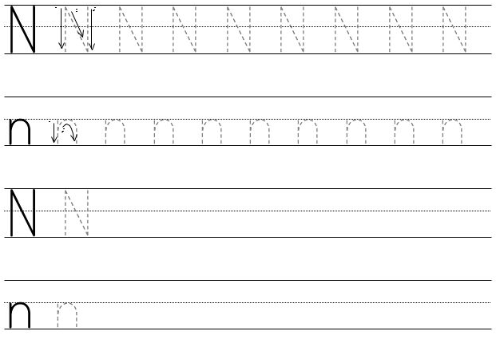



**Tracing Letter “Oo”**

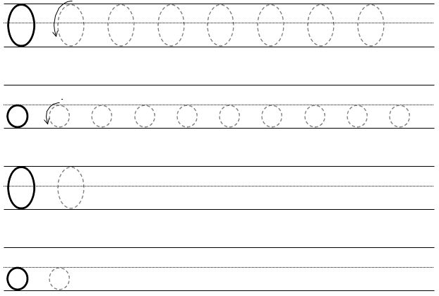



**Tracing Letter “Pp”**

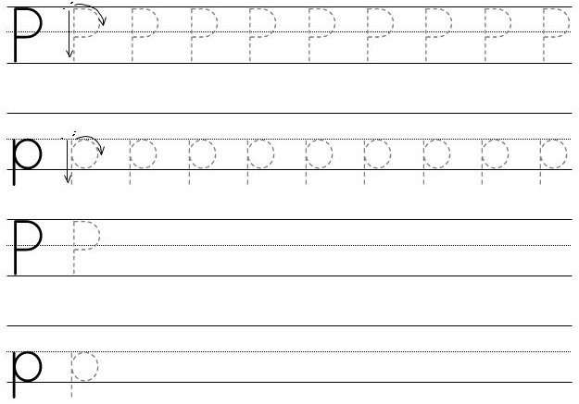



**Tracing Letter “Qq”**

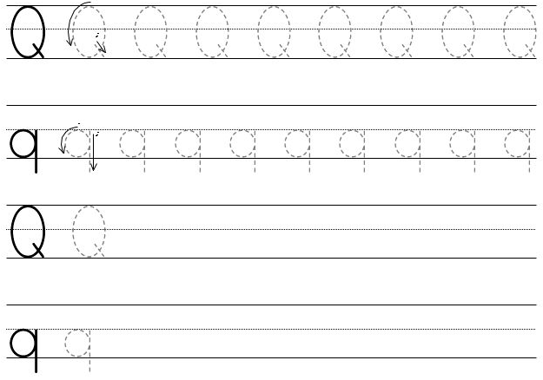



**Tracing Letter “Rr”**

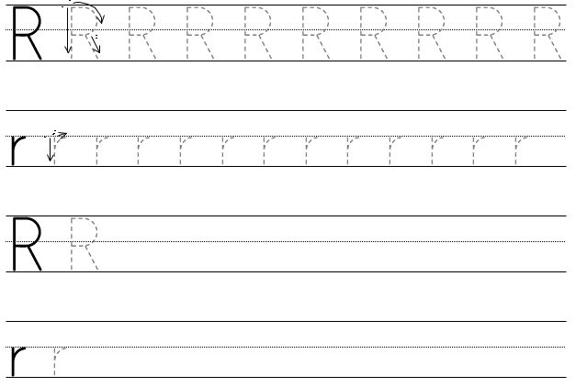



**Tracing Letter “Ss”**

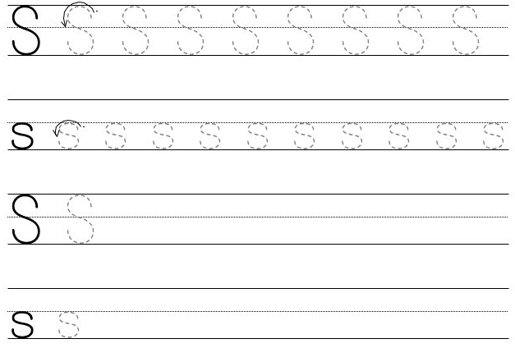



**Tracing Letter “Tt”**

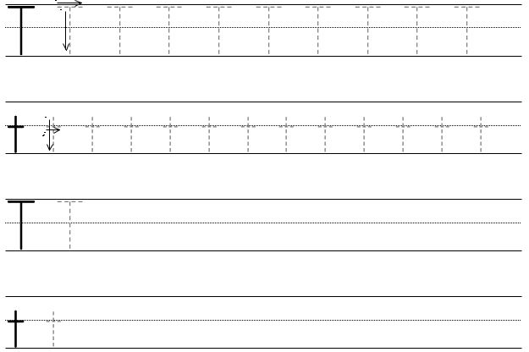



**Tracing Letter “Uu”**

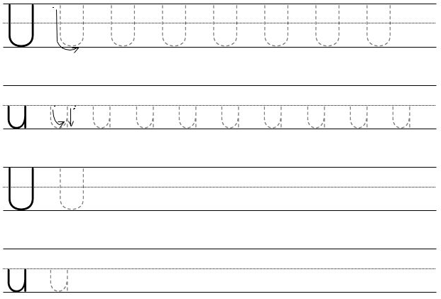



**Tracing Letter “Vv”**

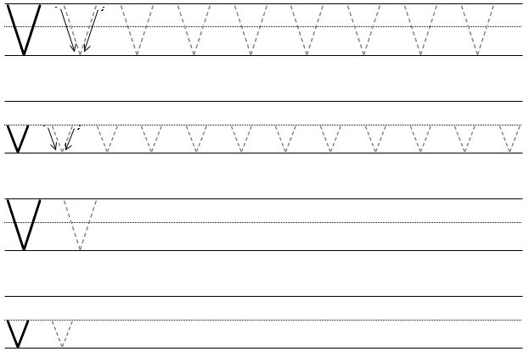



**Tracing Letter “Ww”**

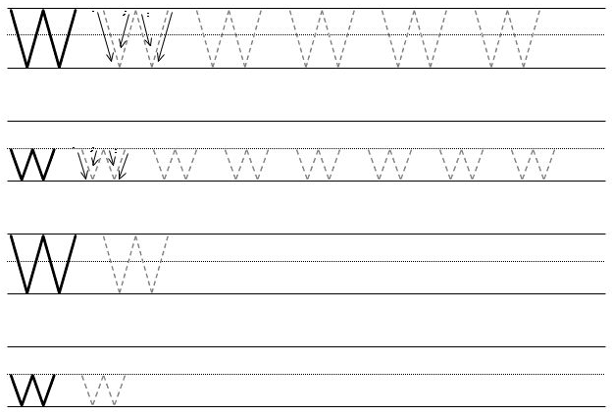



**Tracing Letter “Xx”**

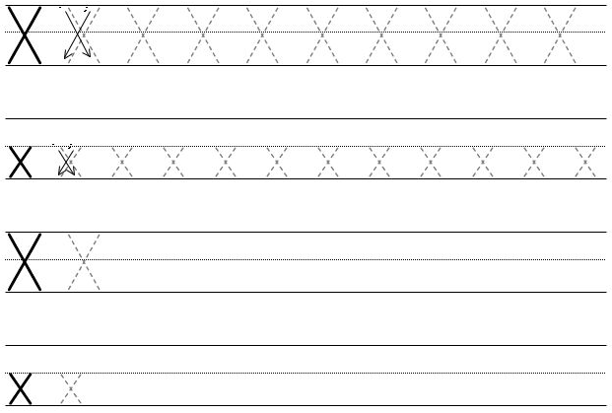



**Tracing Letter “Yy”**

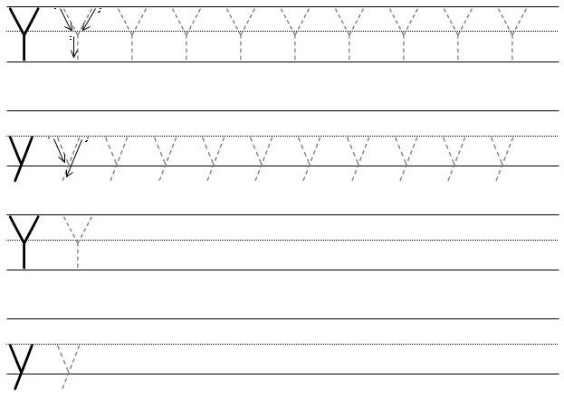



**Tracing Letter “Zz”**

